**INDEX**

1. Introduction ---------------------

2. Purpose ------------------

3. Project Scope ------------------

4. Project Audience ------------------

5. System Architecture ------------------

6. Functions ------------------

6.1 int show_customer ()

6.2 int add_product () ------------------

6.3 int modify_tock() ------------------

6.4 int file_maintainance () ------------------

6.5 int customer_registration() ------------------

6.6 int consult_order() ------------------

6.7 int show_product() ------------------

6.8 int checkout () ------------------

6.9 int new_order () ------------------

6.10 int show_all_orders() -----------------

6.11int show_delivery() ------------------

6.12 int begin_delivery() ------------------

7. UML Diagrams -------------------

7.1 sequence Diagram -------------------

7.2 Class Diagram ----------------------- -------------------

8. ER Diagram -------------------

9. Data Flow Diagram -------------------

* **Introduction**

The Oozy Online Snack Delivery Bar is a menu driven online shopping system that allows user to search through the snacks and buy maximum three types of snacks at a time. Program allows the customer to view snacks details and order them, and all these changes are stored and can be viewed anytime by the employee. Only an authorized company person is allowed to update customer and snacks database. Delivery of orders is based on descending order of distance entered by the customer that is the customer nearest to the snack bar will receive the order first.

* **Purpose**

Main objective of The Oozy Online Snack Delivery Bar is to provide users a better and convenient interface to order snacks online. This online portal can also be beneficial in bridging the gap between sellers and consumers. This is an user-friendly menu based system for both customer and employees.

* **Project Scope**

This project aims to create a user-friendly online snacks delivery system where user is allowed to buy maximum of three type of snacks at a time. It can generate a detailed sales invoice. All the information about a particular customer or a product is stored in a retrievable manner.

* **Project Audience**

The audience are the people who wants to buy snacks online using this online snacks delivery system.

* **System Architecture**

**The Oozy Online Snack Delivery Bar**

This is a menu driven online snacks delivery system that allows user to search through the snacks and buy maximum three types of snacks at a time. In this online snack delivery system orders are delivered based on distance entered by the customer. Program allows the user to view snacks details and purchase item, and all these changes are stored and can be viewed anytime. Only an authorized company person is allowed to update customer and snacks database.

**Function:**

**6.1 int show_customer_list();**

This function allows the employee to view the customer’s details i.e name, customer_id, phone number,email_id and custtomer id is generated automatically.

**6.2 int add_product();**

This function allows the employee to add product name,product description,units available,price and product id is generated automatically.

**6.3 int modify_product();**

This function takes product id as input and ask the employee to modify stock details that is name,description,units available,unit price and also have an option to delete the product.

**6.4 int modify_customer();**

This function takes customer id as input and ask the employee to change the customer details that is name,phone no,email and also have an option to delete customer.

**6.5 int file_maintenance();**

This is password authenticated function accesible only for employees having a sub menu to add product,modify stock,modift customer and to view customer list.

**6.6 int customer_registration();**

This function allows the customer to register themself to the oozy snack online delivery system by adding details like name,email,phone no and password.

**6.7 int consult_order();**

This function shows the details of the order after entering order id.

**6.8 int show_products();**

This function shows all the available snacks list to the customer and employee in the snack bar menu.

**6.9 int checkout();**

This function allows customer to checkout after the snack purchase of maximum three items.

**6.10 int new_order();**

In this function customer has to enter phone no and password and after validation they are allowed to place an order of maximum three snacks .

Customer also has to enter the distances between snack bar and their delivery location.

**6.11 int show_all_orders();**

This function displays all the orders placed by the customer in an organised format.

**6.12 int show_delivery();**

This function shows the delivery list in descending order of the distance.

**6.13 int begins_delivery();**

This function begins the delivery in descending order of the distance.

* **UML Diagram**

**Sequense Diagram**



**Class Diagram**

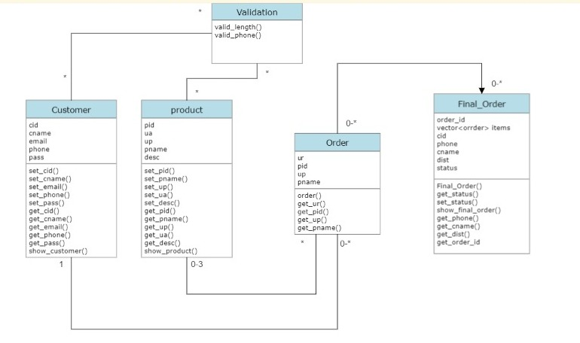

* **ER Diagram**



* **Data Flow Diagram**

**Level 0**



**Level 1**

